🗂️ YUEDU Shredders Product Catalog

Documents · Metals · Plastics · Composites · Shredding Systems

Empowering Global Industries with Shredding Solutions.

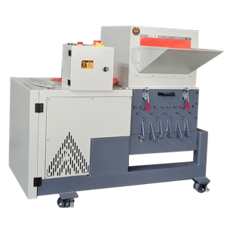 | 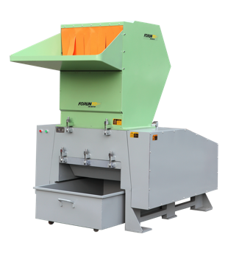 | 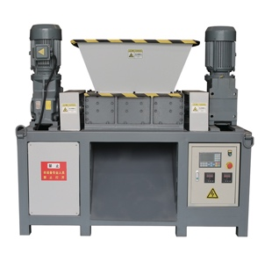 | 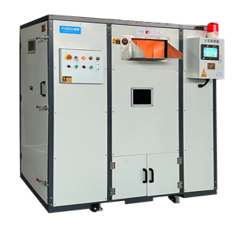
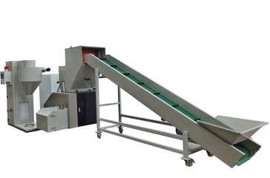 | 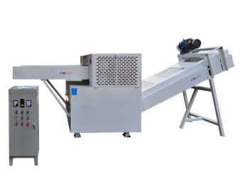 | 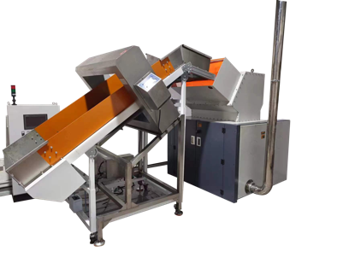 | 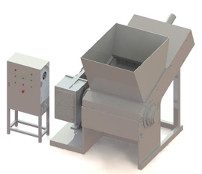
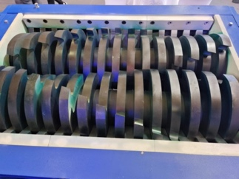 | 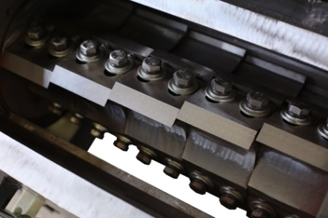 | 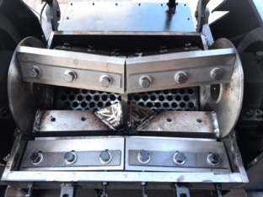 | 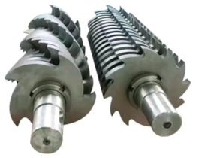
Shanghai YUEDU Technology Co., Ltd. is a Shanghai-certified high-tech enterprise specializing in the development and manufacturing of shredding and destruction equipment. We serve a wide range of sectors including government agencies, financial institutions, military departments, enterprises, and recycling industries.
Our offerings include office and industrial-grade paper shredders, hard drive destroyers, plastic crushing systems, and fully customized destruction center solutions. From design to delivery, we help clients achieve efficient, secure, and compliant material destruction.

🎯 Our Mission
We are dedicated to the shredding and destruction industry, continuously solving diverse material shredding and disposal challenges for our clients around the world.
💡 Our Core Values
📚 Aligned with Buffett and Munger  👥 User-Centric Operations  🌱 Commitment to Long-Termism | 🤝 Integrity First  🧠 Common Sense & Customer Value
Global Shredding Solutions

Quality Assurance and Certifications

CE  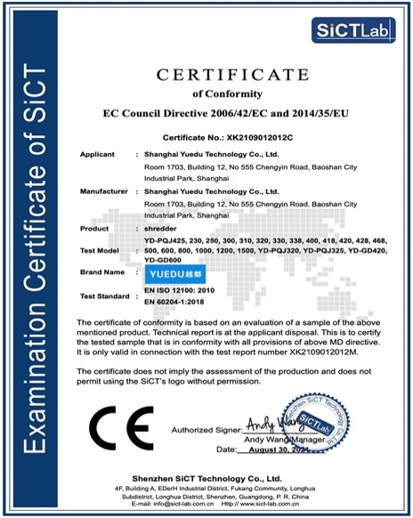 | Shanghai High-Tech Enterprise Certificate 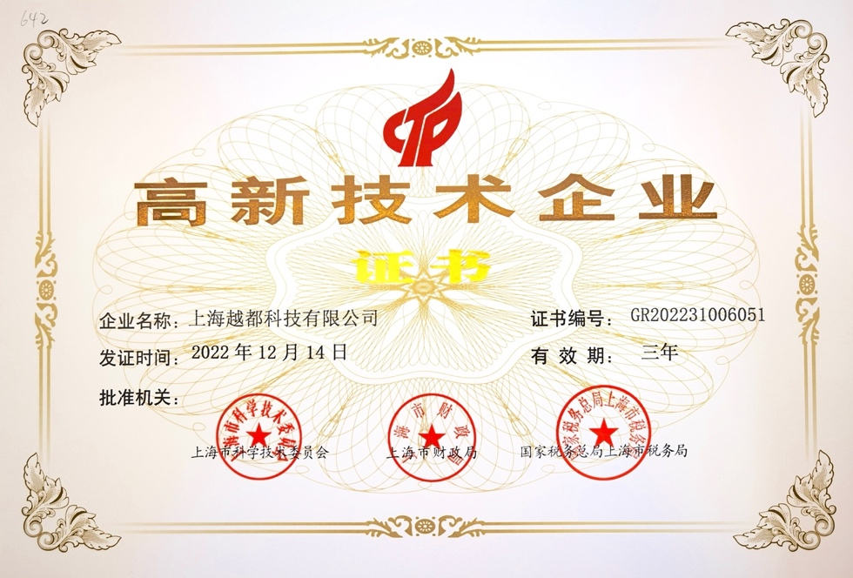

Book / Paper / Hard Drive Shredding Effectiveness
